**AGE CALCULATOR**

**APPLICATION USING GNUSim8085s**

**NAME: SAPNA YADAV**

**CLASS: SYBSCIT**

**ROLLNO: 18073**

**SUBJECT: VSC (PROJECT)**

**SUBMITTING TO: GAYATRI MAM**

**AIM:** **To write an 8085 assembly language program that checks if a person is a Minor or an Adult based on their age**

**Algorithm:**

**1. Start the program.**

**2. Load the age value from memory location 2050H.**

**3. Compare it with 18 (12H), the legal adult age.**

**4. If the age is less than 18 → store 00H in 2051H (Minor).**

**5. Otherwise → store 01H in 2051H (Adult).**

**6. Stop the program.**

**PROGRAM:**

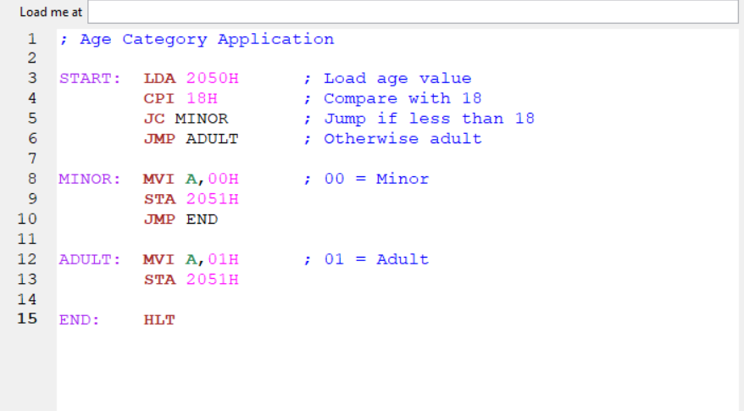

**OUTPUT:**

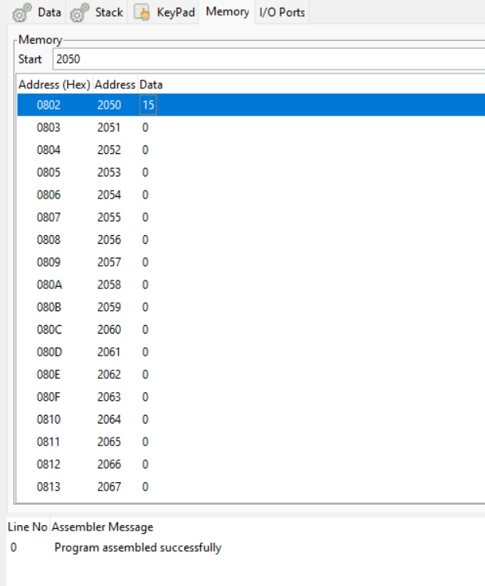

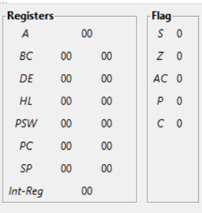

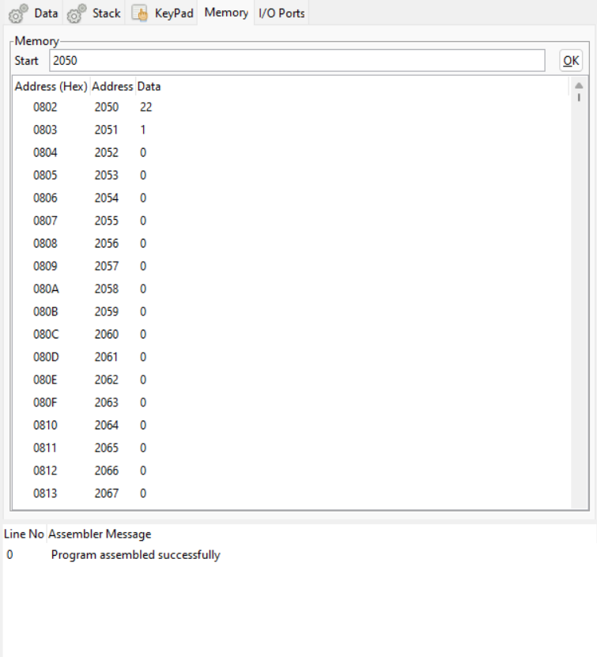

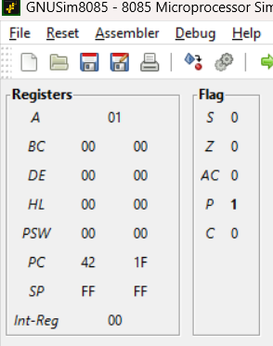

OUTPUT TABLE:

Input (2050H) Output (2051H) Meaning

15 00 Minor

22 01 Adult

Result:

The program successfully checks the given age and classifies the person as Minor or Adult.

The result is correctly stored in memory location 2051H.

**CONCLUSION:** The above program has been executed successfully.

**THANKYOU**